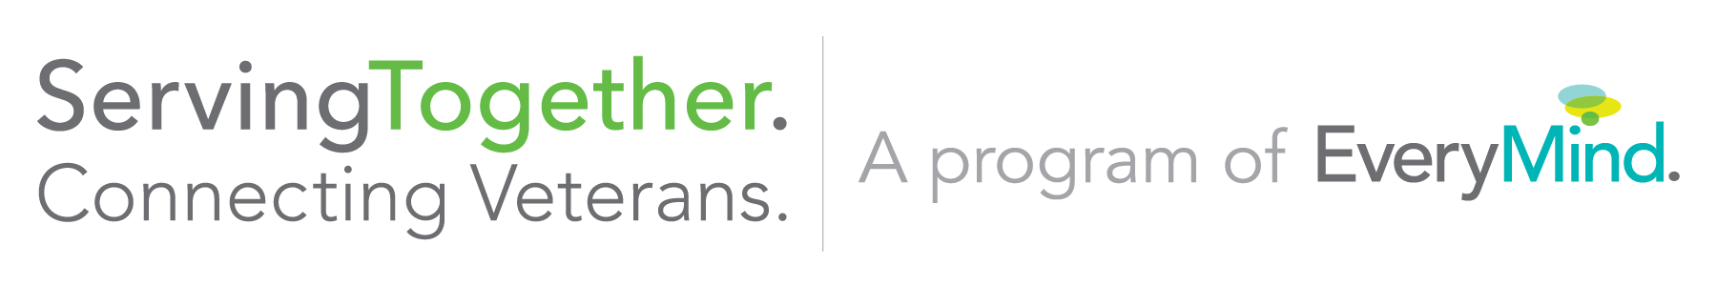
Fairfax County Veterans Collaborative Meeting
Tuesday, April 3 @ 1 pm
Tysons-Pimmit Library, Falls Church

- Introductions

- Presentations / Q.&A.
- Entrepreneurship Programs Discussion with:
- Greg Manzur – The Entrepreneur Source
- Lee Dougherty – Objective Rally Point
- Keith Streicher – WeWork Veterans in Residence Program

- Veteran Issues and Discussion
- Any veteran issues or needs you need assistance from the collaborative with?

- Updates and Announcements from Collaborative Members
  - April 4: DC Hire Vets (DC)
  - April 19 & 26: VEI Vetworking Cohort (Tysons)
  - April 26: DC Bourbiz Veteran/Military Spouse Resource Event (DC)
  - May 24-June 3: Vetoga Yoga Teacher Training (Alexandria)
  - July 30-Aug 3: Warrior Herd Gold Star Family Camp (Purcellville)

**2018 Fairfax County Veterans Collaborative Meeting Schedule**
June 5, August 7, October 2, December 4
1 – 3 pm, Location: TBD

Contact Christy at ckenady@every-mind.org if interested in presenting or hosting the collaborative.
Fairfax County Veterans Collaborative Charter
Overview: The Fairfax County Veterans Collaborative was introduced in June 2015 by ServingTogether, a program of EveryMind. The Collaborative is chaired by ServingTogether’s Northern Virginia Program Manager.
Purpose: ServingTogether seeks to transform a current fragmented system of care that primarily reacts to service member, veteran and family inquiries to one that rallies the entire community to proactively create a safety net of easily accessible services. We seek to identify the multiple points of entry service members, veterans, and families may be accessing and coordinate those resources more effectively. Gaps in services and care will be highlighted and strategies for filling those gaps will be developed. Ultimately, increased identification, referral and coordination of community based and military services will result in greater alignment of resources to strengthen health and mental health outcomes for service members, veterans and their families.
Mission of the Fairfax County Veterans Collaborative: The Collaborative is a grass roots program to assist Fairfax County's service to veterans by coordinating similar efforts undertaken by community leaders, nonprofits, veterans service organizations, and local government to ensure that services are not being duplicated, and veterans receive the best possible information and access to care and benefits.
Goal: Coordinate efforts between Fairfax County community organizations and county, state, and federal partners that serve the military and veteran community. Meetings are used for networking, information sharing and analysis of needs. The collaborative members will work to develop additional partnerships and collaborations to ensure efforts are coordinated.
Structure and Membership: The Collaborative will meet every other month on the first Tuesday from 1 – 3 pm. The meetings are free and open to the public. County, state, federal organizations, nonprofits, and other community organizations that support military, veterans and their families are encouraged to attend. Veterans are encouraged to attend.
Interested in attending?
Contact Christy Kenady at ckenady@every-mind.org or 703-288-5355 to be added to the distribution list and for further information on the meeting.

