**ServingTogether Highlights – September 2018**

ServingTogether’s Provider network is growing! We are up to [77 provider organizations](https://servingtogetherproject.org/veteran-services/) with 170 individual users in the network, with more coming onboard every month!

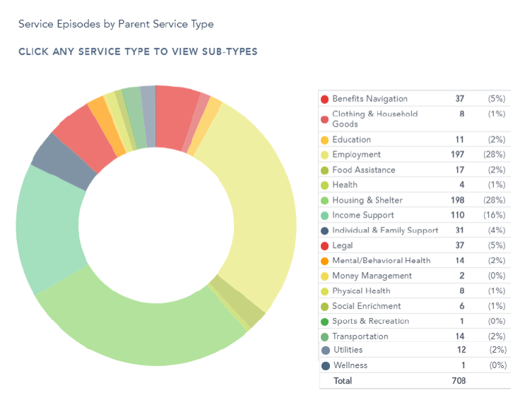We are four months post-launch, and so far we have created over 700 service cases for 316 veterans, caretakers, and family members.

So far our greatest areas of need, across the entire region have been Employment (28%), Housing (28%), and Financial Assistance (16%), Benefits Navigation (5%), and Legal Assistance (5%). We are incredibly grateful to our providers that have been able to assist us in meeting these veteran’s needs.

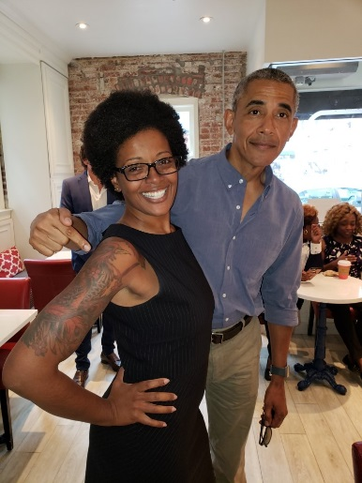

**New Team Member – Alicia Downs**

We are also very excited to announce our new team member. Alicia Downs has joined our team and will be the Program Manager for the District of Columbia, Prince George’s County, and southern MD. Alicia comes to us with a wealth of experience across non-profit, corporate, military, and government sectors.

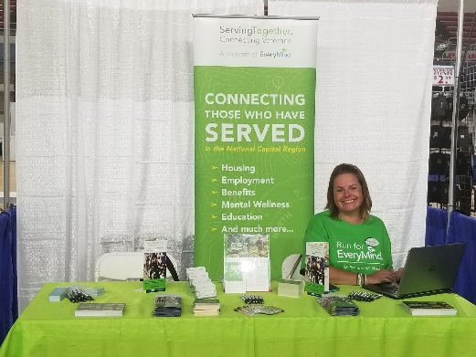**Have you seen us?**

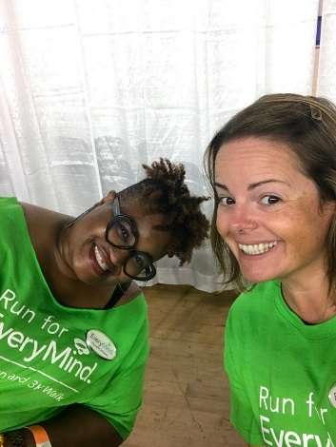ServingTogether has been busy the month of September attending several events including the DC VA Mental Health Summit, Fairfax-Falls Church Community Services Board Recovery Resource Open House, RunforEveryMind, Make Room Home Health and Finance event, ArtsSpace Ground Breaking, Gaithersburg CBOC Grand Opening, Warrior Community Integration Symposium, and so much more! Check out our awesome Peer Navigators, Chenille Johnson and Jennifer Watson representing us at the Navy-Air Force Half Marathon on September 14!

**ServingTogether Collaboratives**

ServingTogether will be hosting and/or support several [community-level veteran collaborative meetings](https://servingtogetherproject.org/collaboratives/) in October.

|  |  |  |  |
| --- | --- | --- | --- |
| **Community** | **Date** | **Time** | **Location** |
| [Fairfax County Veterans Collaborative](https://servingtogetherproject.org/collaboratives/fairfax-county-veterans-collaborative/) | October 2, 2018 | 1 – 3 pm | Tysons-Pimmit Library (Falls Church, VA) |
| [Southern MD Veterans Collaborative](https://servingtogetherproject.org/collaboratives/southern-maryland-veterans-collaborative/) | October 4, 2018 | 10 am – 12 pm | Charlotte Hall (Charlotte Hall, MD) |
| [Washington, D.C. Community Collaborative](https://servingtogetherproject.org/collaboratives/dc-community-collaborative/) | October 9, 2018 | 1 – 3 pm | TBD |
| [Fort Belvoir Collaborative](https://servingtogetherproject.org/collaboratives/fort-belvoir-collaborative/) | October 18, 2018 | 12 – 2 pm | USO (Fort Belvoir, VA) |
| [Frederick Veteran Support Network](https://servingtogetherproject.org/collaboratives/frederick-veteran-support-network/) | October 23, 2018 | 9 am – 10:30 am | Mount St. Mary’s University Frederick Campus (Frederick, MD) |
| [Loudoun County Veterans Collaborative](https://servingtogetherproject.org/collaboratives/loudoun-county-veterans-collaborative/) | October 31, 2018 | 1 – 3 pm | Paul Davis Restoration (Ashburn, VA) |

Please check our [events calendar](https://servingtogetherproject.org/washington-dc-veteran-events/) for more info on times and locations.

**In need of assistance?**

If you are a servicemember, veteran or family member in need of assistance, please fill out the [Get Assistance Form](https://servingtogetherproject.org/washington-dc-veteran-assistance/) on our website or give us a call at 1-855-738-7176.