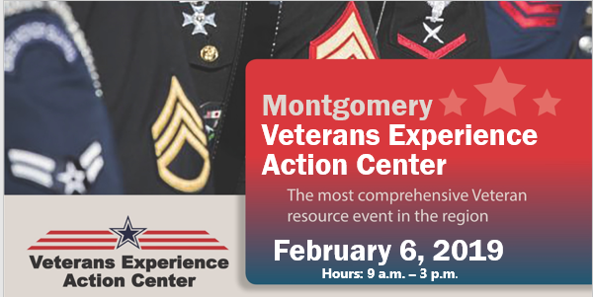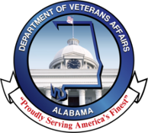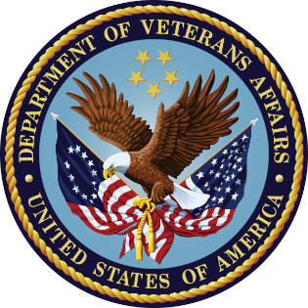

Dear Valued Veteran Service Partner,

On the 6th of February 2019 the United States Department of Veterans Affairs (VA) and the Alabama Department of Veterans Affairs (DVA) invites your organization to participate in providing benefits, services and support to the Veterans, families, caregivers and survivors (customers) during the first Veterans Experience Action Center to be held in the great state of Alabama.

The Veterans Experience Action Center (VEAC) has been conducted in many locations throughout the United States since 2014; including North Carolina, Ohio and Missouri. This event focuses on personal engagement while striving to identify and resolve the specific issues of that customer. The positive financial and emotional impact of these events on those that we serve is measured in dollars and many times in laughter and tears of joy.

While the VA and DVA assist in resolution of many customer issues it is recognized that other government agencies and community partners are, in many cases, the most valuable resource for resolving problems experienced by our heroes and those they hold dear*.*

Should you choose to accept this invitation to service customers on behalf of your organization you will receive an event layout plan and a list of items needed to provide services at this event. Please consider joining us in service at this inaugural event in Montgomery, AL.

Please respond with your intent to join as by contacting Dorian Jenkins at [dorian.jenkins@va.gov](mailto:dorian.jenkins@va.gov) no later than 25 January 2019.

Sincerely in Service,

Corey Hawthorne xxxxxxxxxxxxx

Director Director

Alabama VA Regional Office Alabama Department of Veterans Affairs