**Keynote Speaker**

*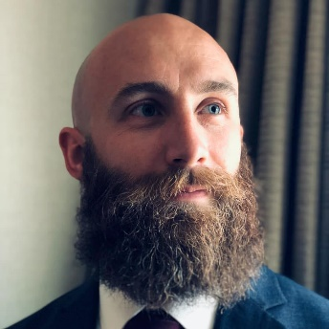Kristofer Goldsmith*

Kristofer Goldsmith is the founder and president of High Ground Veterans Advocacy, a 501c3 not-for-profit, which partner’s with military and Veterans Service Organizations to train veterans to become grassroots advocates and leaders in their local communities. High Ground Veterans Advocacy was recognized in 2016 by Hill Vets as one of the nation’s top new veteran’s organizations.

Kris was born in New York and joined the Army to serve as a forward observer with the Army’s Third Infantry Division shortly after the Sept. 11, 2001, terrorist attacks. He deployed with Alpha Company of the Third Battalion, 15th Infantry Regiment, in support of Operation Iraqi Freedom for the year of 2005. Since separating from the Army with a General Discharge after surviving a PTSD-related suicide attempt, Kris has become an advocate for veterans with PTSD and those with less-than-honorable discharges. Twelve years after his separation from the military, the Army corrected his discharge characterization to Honorable.

As a disabled student veteran using the VA’s Vocational Rehabilitation program, Kris found an opportunity both to recover from PTSD and to continue serving his fellow veterans. At Nassau Community College (NCC), he established a million-dollar veteran-resource facility, which serves as a center for hundreds of student veterans. After two years as president of NCC’s Student Veterans of America chapter, he transferred to Columbia University’s School of General Studies where he recently received a bachelor of arts in political science. From 2016-2020, Kris worked on the policy and to develop and see implemented the congressional budgetary trick that removed the delimiting date for what became the "Forever GI Bill." As VVA's chief investigator, he wrote the definitive work on foreign entities that target troops, veterans, and their families online. He believes it is the responsibility of today’s young veterans to keep the motto of Vietnam Veterans of America alive: “Never again will one generation of veterans abandon another.”

**Lethal Means**

*Presenter:* 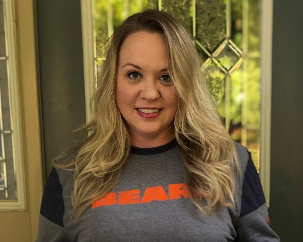

*Megan Flaherty*

Megan graduated from University of Nevada, Las Vegas, in 2004 with a Masters in Social Work and has been working in the mental health field since then. She has worked in the community at the beginning of her career since working Jesse Brown VAMC in Chicago in 2007. She has been working with veterans and active duty military ever since. Megan worked at Fort Belvoir for 2 years and has been at the Hampton VAMC since 2018. Her experience providing mental health services has covered the gamut from outpatient therapy, to ED and crisis management, to inpatient psychiatry.

When she joined Hampton VAMC, she started working in outpatient mental health providing therapy and case management to the SMI population. In March 2020, Megan joined the Suicide Prevention Team as a Case Manager and was promoted to Coordinator in June.

**The Community Impact on Suicide Prevention**

*Moderator & Panelist:***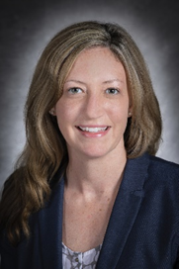**

*Brandi Jancaitis*

Brandi Jancaitis brings extensive personal and professional experience in programs and services for military and veteran families. She currently serves as the Director of the Virginia Veteran and Family Support (VVFS) Program at the Virginia Department of Veterans Services (VDVS). VVFS is a statewide program that provides peer and family support and behavioral health and supportive services linkages to Military Service Members, Veterans, and their Families (SMVF). She also leads regional and statewide suicide prevention efforts for SMVF in partnership with the Veterans Health Administration and Substance Abuse and Mental Health Services Administration including the Richmond Mayor’s Suicide Prevention Challenge and statewide Governor’s Suicide Prevention Challenge teams. Brandi also served as the Director of Housing Development for Veterans for VDVS and worked on the statewide effort to reach the functional end to Veteran Homelessness in Virginia. At the Virginia Department of Behavioral Health and Developmental Services (DBHDS), Brandi served as the first Military and Veterans Affairs Director and helped enhance treatment and supportive services for SMVF in the public mental health system. Prior to state-level roles, Brandi worked at Richmond Behavioral Health Authority, a Public Mental Health Center, in research and grant development, program evaluation, and prevention services. Brandi is from Southwest Virginia and a graduate of Virginia Tech and Virginia Commonwealth University. Brandi is a military spouse and lives in Virginia with husband Nicholas and their three children.

*Panelists:*

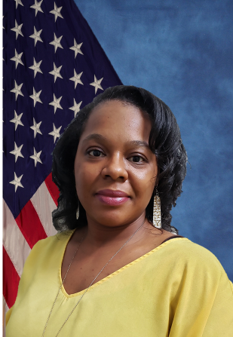**Sheronda Farrow, PhD, LCP**

Dr. Sheronda Farrow is a Licensed Clinical Psychologist who currently serves as the psychologist for the Suicide Prevention Team at the Hampton VA Medical Center. Dr. Farrow has gained experience working with a wide variety of individuals; providing risk assessment, crisis intervention, outpatient mental health services, psychological evaluation, and forensic services. Dr. Farrow provides consultation and training for healthcare professionals and others within the VAMC and surrounding community.

*Crisis Services and Suicide Prevention*

* Currently serves as the Clinical Psychologist for the SP Team at the HAMVAMC
* Previously served as the Administrator of Emergency and Crisis Services with one of the largest CSBs in the state of Virginia (WTCSB)
* Involved in several community collaboratives involving crisis services and suicide prevention, that include work with law enforcement, educational authorities, state and local government entities, community service boards, VSOs, faith-based org, and other service providers
* Trainer of SAVE, MHFA, CIT, ASIST, etc.
* Provide numerous educational workshops and trainings on crisis services, crisis intervention and suicide prevention at state conferences, VHA conferences and in-services, and community-based trainings at various private and local government entities

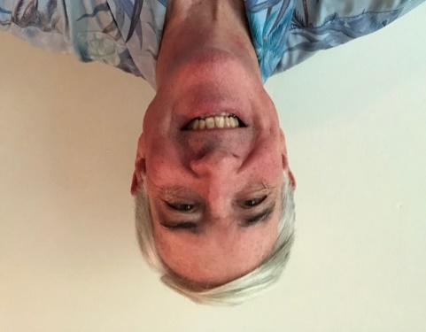

**Greg Reuss**

Greg Reuss serves as Board Chair (Volunteer) for the Maryland Chapter of the American Foundation for Suicide Prevention (AFSP). His focus areas include suicide prevention education, advocacy and coalition building. Mr. Reuss retired from the U.S. Marine Corps in 2007, having served 30 years in a combination of operational and staff assignments. He then worked in the defense industry through 2016. He is a graduate of the U.S. Naval Academy and Naval Postgraduate School. He graduated from Salisbury University earning a Master of Social Work degree. Mr. Reuss is an active community volunteer and Licensed Master Social Worker.

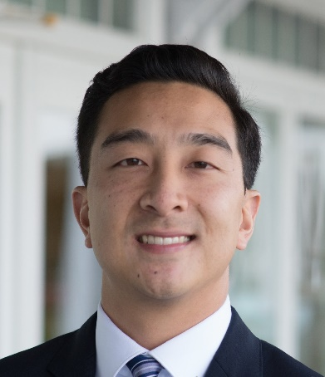**Adam Chu**

Mr. Chu is Director of Health and Behavioral Health Initiatives with the Suicide Prevention Resource Center (SPRC) project. In this position he leads projects that build capacity to deliver effective suicide prevention services across states, communities, and civilian health systems and military treatment facilities, including emergency departments, primary care, and inpatient and outpatient settings. Mr. Chu has provided consultation to SAMHSA Zero Suicide, Garrett Lee Smith Youth Suicide Prevention, and National Strategy for Suicide Prevention Grantees. He serves as a suicide prevention subject matter expert for the VA/SAMHSA Governor’s and Mayor’s Challenges to Prevent Suicide and also works with the Manchester, NH VA Medical Center in their implementation of Zero Suicide. Mr. Chu obtained his BS from Tufts University and his MPH from the Boston University School of Public Health.

**Preventing Suicide: A Clinical Approach**

*Presenter:*

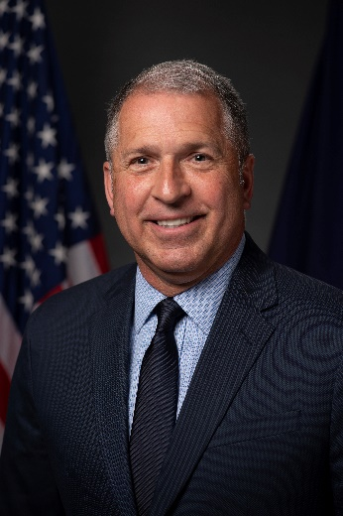**Jim McDonough**

Colonel (U.S. Army, Retired) James (Jim) D. McDonough, Jr., is the Executive Director of Headstrong, a leading mental health treatment practice for military connected individuals. Prior to serving as Executive Director, Jim served in a number of key leadership assignments in the veterans’ sector, including two stints as Director of the New York State Division of Veterans’ Services, Senior Fellow for Veterans Affairs within the New York State Health Foundation and Managing Director of the Institute for Veterans and Military Families (IVMF) at Syracuse University, where he was responsible for the global deployment of the Institute’s widely recognized programs and services. Jim also served as Chief Executive Officer for Veterans Outreach Center in Rochester, New York, where he led the nation’s oldest continuing serving nonprofit dedicated to the needs of military connected individuals and families.

Jim was commissioned an Air Defense Artillery Officer upon graduation from Officer Candidate School, Class 1-82 on March 11, 1982. Following graduation, he attended the Air Defense Artillery Officer Basic Course, Improved Hawk Weapons Course and the Air Defense Command and Control Course at Fort Bliss, Texas. He is a graduate of the Army’s Airborne School at Fort Benning, Georgia. His first assignment was as Platoon Leader, Battery C, 1st Battalion, 1st Air Defense Artillery Regiment, Fulda, Germany. Following a stint as Brigade Electronic Counter-Counter Measures Training Officer, 10th Air Defense Artillery Brigade, Darmstadt, Germany, he returned to Fort Bliss, Texas, to attend the Air Defense Artillery Officer Advance Course and PATRIOT Weapons Course. Upon graduation he returned to Germany and assumed command of Battery A, 4th Battalion, 3rd Air Defense Artillery, Giessen, Germany, where he commanded for twenty-nine months.

Following command, he was selected to participate in the Army’s Advanced Civil Schooling Program at Indiana State University where he earned an M.A. in Communications. Following graduate school, he was assigned as Strategic Planner in the Office of the Chief of Public Affairs and then Speechwriter to then Secretary of the Army, the Honorable Togo D. West. From 1995-1996 he served as Battalion Operations and later, Executive Officer, for 1st Battalion, 43rd Air Defense Artillery Regiment, Suwon, Republic of Korea. Following Korea, he reported to the Joint Staff, Operations Directorate, for three years. COL McDonough was selected to command the 3rd Battalion, 43rd Air Defense Artillery Regiment, Fort Bliss, Texas, where he commanded from 1999-2001. In 2001 he was selected to attend the United States Army War College, Centennial Class, and Carlisle, Pennsylvania. Following the Army War College, he was assigned to the United States Military Academy, West Point, as Professor of Outreach, the Simon Center for the Professional Military Ethic. In 2003 Jim deployed as G3, Current Operations Officer, 32d Army Air and Missile Defense Command, Camp Doha, Kuwait, for OPERATION IRAQI FREEDOM.

Colonel (Retired) McDonough was awarded the Bronze Star Medal, Legion of Merit Medal (w/1OLC), Defense Meritorious Medal, Meritorious Service Medal (w/2OLC), Joint Staff Commendation Medal (w/1OLC), Army Commendation Medal (w/5OLC), Joint Service Achievement Medal, Armed Forces Expeditionary Medal, the Global War on Terrorism Expeditionary and Service Medals, the Korean Defense Service Medal, the Armed Forces Reserve Medal, the Army Service Medal, and Overseas Service Ribbon (w/2OLC). During his service he wore the Joint Chiefs of Staff Identification Badge, the Army Staff Identification Badge, and Parachutist Badge.

Jim is pursuing his Ph.D. in law and policy from Northeastern University with an anticipated completion date of June, 2022.