**Operation**

**S.A.V.E.**

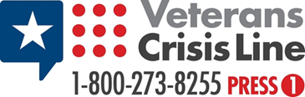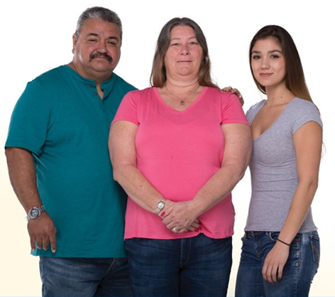

**WHO:** Families and friends of Veterans or others

who may be at increased risk for suicide.

**WHERE: Virtual Web-ex Meeting\***

**SESSIONS: 3rd Monday of the Month**

Even Months at 10AM (February, April, June, August, October, December)

Odd Months at 1PM (January, March, May, July, September, November)

**TO REGISTER:**

**Morning Sessions:** <https://veteransaffairs.webex.com/veteransaffairs/k2/j.php?MTID=tbdde3e6ebaf9412ba06164407841b4e0>

**Afternoon Sessions:** <https://veteransaffairs.webex.com/veteransaffairs/k2/j.php?MTID=t70f68e80c7cb7bf022e7a4cf0f2e8eb5>

**\*On-site, in-person training will resume once COVID-19 pandemic restrictions have been lifted.**

**\*\*For additional questions or information, contact Megan Flaherty at**

[**Megan.Flaherty@va.gov**](mailto:Megan.Flaherty@va.gov)

## Gain insight intosuicide and suicide prevention, learn to identify a Veteran that may be at risk, learn steps to assist Veterans at risk, and identify local resources to help.