**PTSD 101 GROUP**

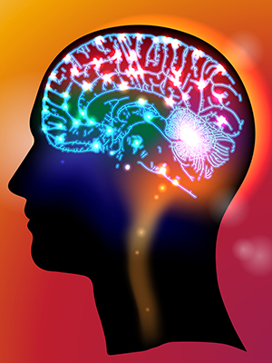

Traumatic experiences produce many different physical and emotional reactions that start in the brain. They are instinctual and can make us feel out of control.

We’ll learn about common reactions to experiencing trauma, how/why the brain creates them, and how to cope.

This group is open to Veterans of all eras. Join us!

**FRIDAYS, starting 8 January 2021**

**10 AM to 11:30 AM**

**ALEXANDRIA VET CENTER**

**6940 SOUTH KINGS HIGHWAY, ALEXANDRIA, VA 22310**

**(703) 360-8633**

**Interested? Talk to your counselor or group facilitator, Rachel Berry**

|  |  |
| --- | --- |
| **Join by Video**   1. Visit <https://veteransaffairs.webex.com> on your internet browser 2. Enter the meeting number: 199 920 1310 3. Enter the meeting password: 2xKxeMhw@55 4. Click “Join Meeting” | **Join by Phone**   1. Dial: (404) 397-1596 (Toll cost will incur if using a landline; please use cell phone) 2. Enter the Access Code: 199 920 1310 |
| **Or Click the Link Below to Join by Video:**  <https://veteransaffairs.webex.com/veteransaffairs/j.php?MTID=m4d7d2f2a8d7d98094df059f2b818da60> | |

 